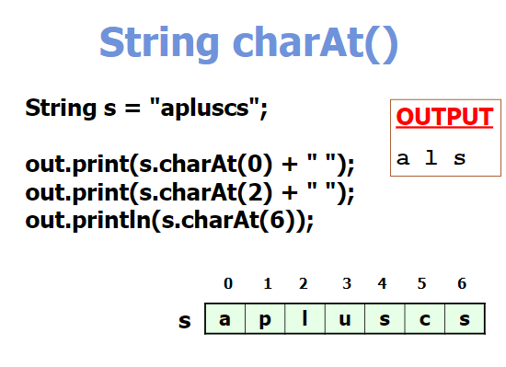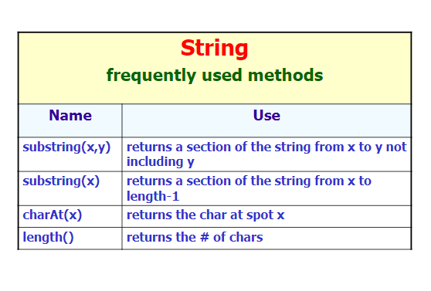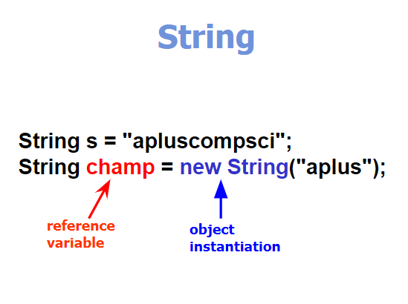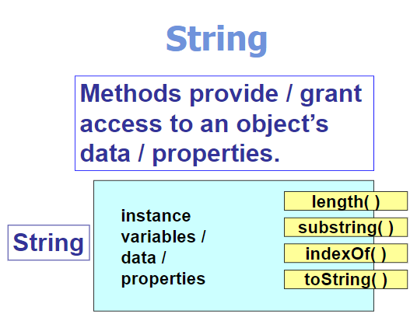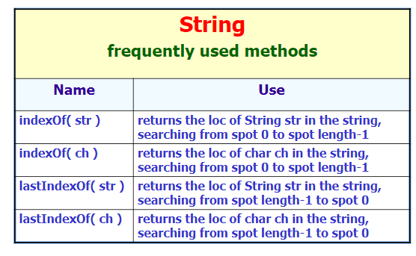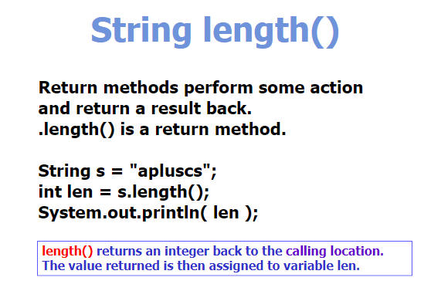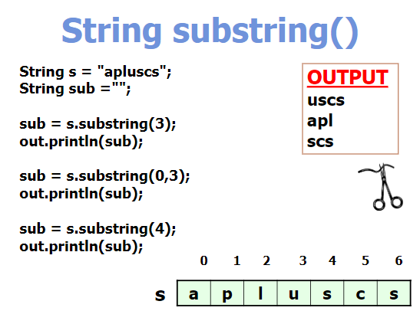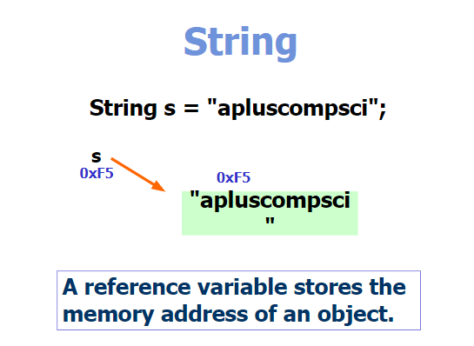

\*\*String is a reference not a primitive data type (IMMUTABLE) 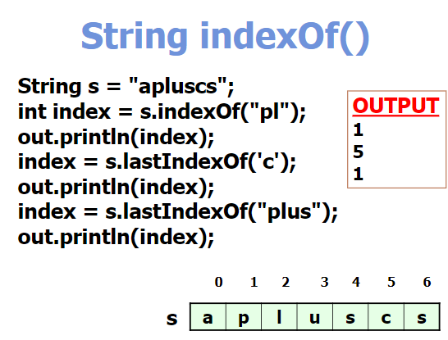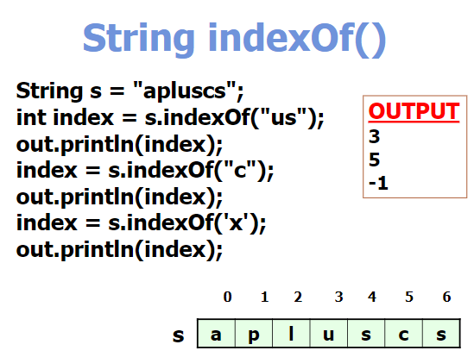

\*\*Spaces count as characters in a String index

\*\*last in index is always ONE LESS the length (if using substring() and trying to get the last index, use the ENTIRE length because .substring() does not INCLUDE the upper bound)

\*\*if it [this.indexOf(“x”)] looks for a String (or char) and doesn’t find it then it would return -1

\*\*indexOf(); returns the first index where the String is found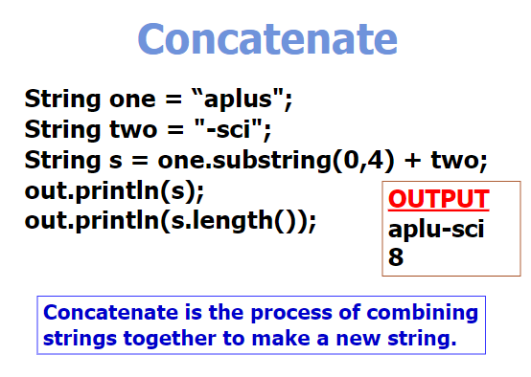

\*\*IF you try to pull (with the scanner) String after a Int, you have to add a keyboard.nextLine(); to catch the ENTER key